KATHMANDU UNIVERSITY

DHULIKHEL KAVRE

**COEG-304:** Instrumentation and Control

Lab Sheet No. 3

**SUBMITTED BY SUBMITTED TO:**

Name: Ayush Kumar Shah Bibek Mahaseth Sir

Roll no: 44 Date of Submission:

Group: CE 3rd year 1st sem 31/01/2018

Level: UNG

**KATHMANDU School of Engineering**

**UNIVERSITY Department of Electrical & Electronics Engineering**

CONTROL ENGINEERING LABORATORY EXERCISE-II

**Example-3**

The block diagram for a simple model consisting of a sinusoidal input multiplied by a constant gain is shown below:



**Ans:**

This model will consist of three blocks: Sine Wave, Gain, and Scope. The Sine Wave is a Source Block from which a sinusoidal input signal originates. This signal is transferred through a line in the direction indicated by the arrow to the Gain Math Block. The Gain block modifies its input signal (multiplies it by a constant value) and outputs a new signal through a line to the Scope block. The Scope is a Sink Block used to display a signal (much like an oscilloscope).

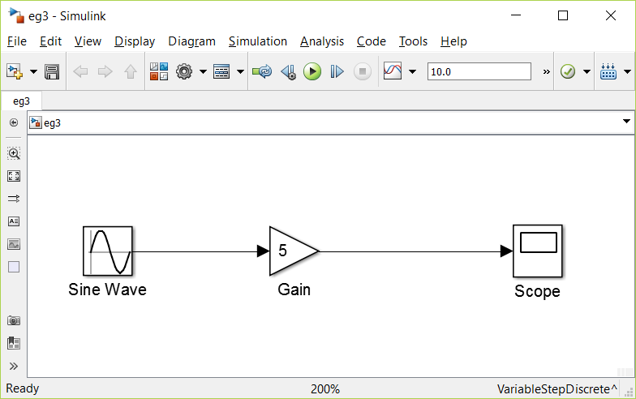

1. Output graph when amplitude of sine wave is 1

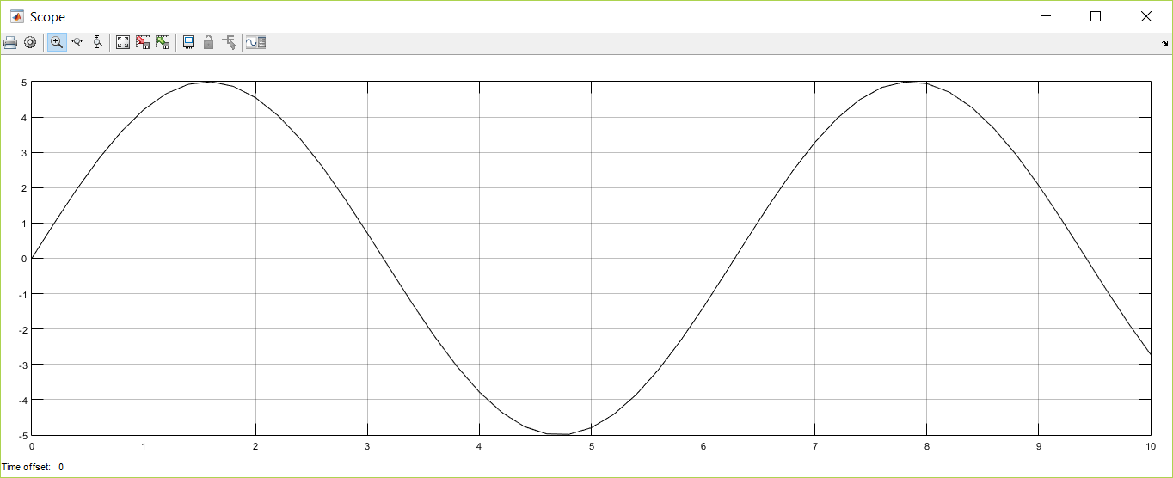

1. Output graph when amplitude of sine wave is 5

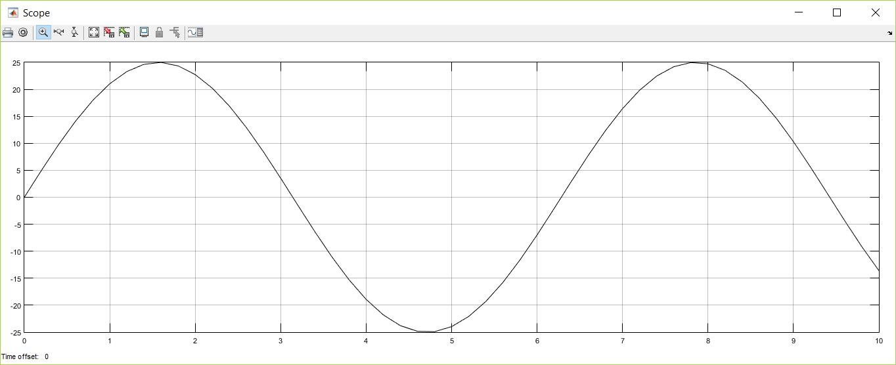

**Example-4**

**Free Body Diagram and System Equation**

Consider the first-order model of the motion of a car. Assume the car to be travelling on a flat road. The horizontal forces acting on the car can be represented as shown in the figure below.

M

v

F

B

In this figure

* v is the horizontal velocity of the car (units of m/s).
* F is the force created by the car's engine to propel it forward (units of N).
* b is the damping coefficient for the car, which is dependent on wind resistance, wheel friction, etc. (units of N*s/m).
* M is the mass of the car (units of kg).

Ans:

The differential equation representing the system is

$$M\frac{dv}{dt}=F-bv$$

Assume that:

M = 1000 kg and b = 40 N*sec/m

This system will be modeled in Simulink by using the system equation as above. This equation indicates that the car's acceleration (dv/dt) is equal to the sum of the forces acting on the car (F-bv) divided by the car's mass,

$$\frac{dv}{dt}=\frac{F-bv}{M}=\frac{F-40v}{1000}$$

To model this equation, insert a Sum block, two Gain blocks and an integrator block into a new model window. Change the parameters of the blocks as per the requirement. Connect the blocks with lines as shown in the figure below.



*System Response to Step Input*

To simulate the system the applied input F is to be specified. Assume that the car is initially at rest, and that the engine applies a step input of F = 400 N at t = 0. This is approximately equivalent to the car's driver quickly pushing down and holding the gas pedal in a steady position starting from a stoplight. Insert a Step block from the Sources subfolder into the model, and also add a Scope block from the Sinks subfolder to monitor the system's velocity, v.

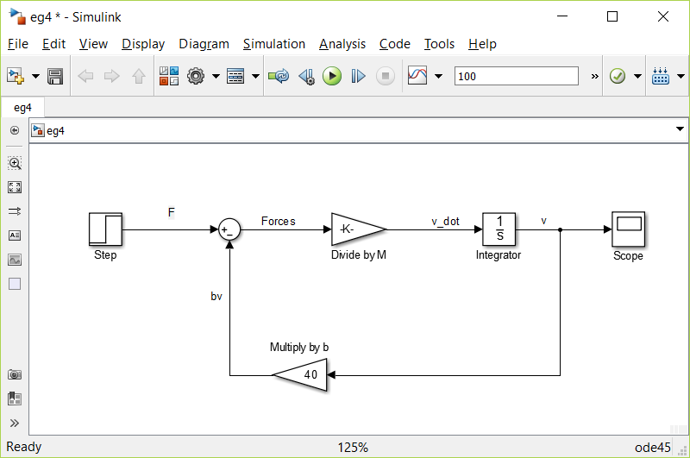

The Step block must be modified to correctly represent the system. Double-click on it and change the Step Time to 0 and the Final Value to 400. The Initial Value can be left as 0, since the F step input starts from 0 at t = 0. The Sample Time should remain 0 so that the Step block's input is monitored continuously during simulation.

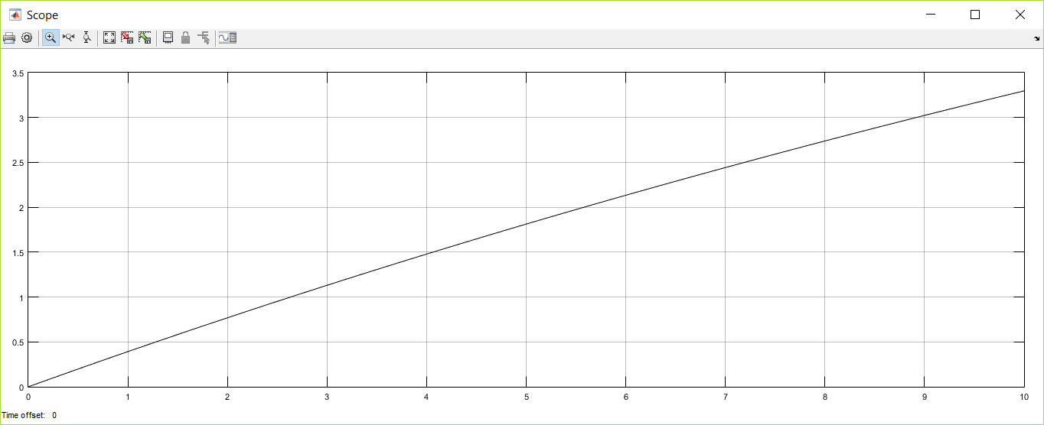

Fig (a): v vs t when stop time=10sec

This graph (a) does not appear to show the velocity approaching a steady-state value, as expected for the first-order response to a step input. This result is due to the settling time of the system being greater than the 10 seconds the simulation was run. To observe the system reaching steady-state, click **Simulation, Parameters** in the model window, and change the Stop Time to 150 seconds. Now, re-running the simulation will result in the velocity graph as shown in (b).

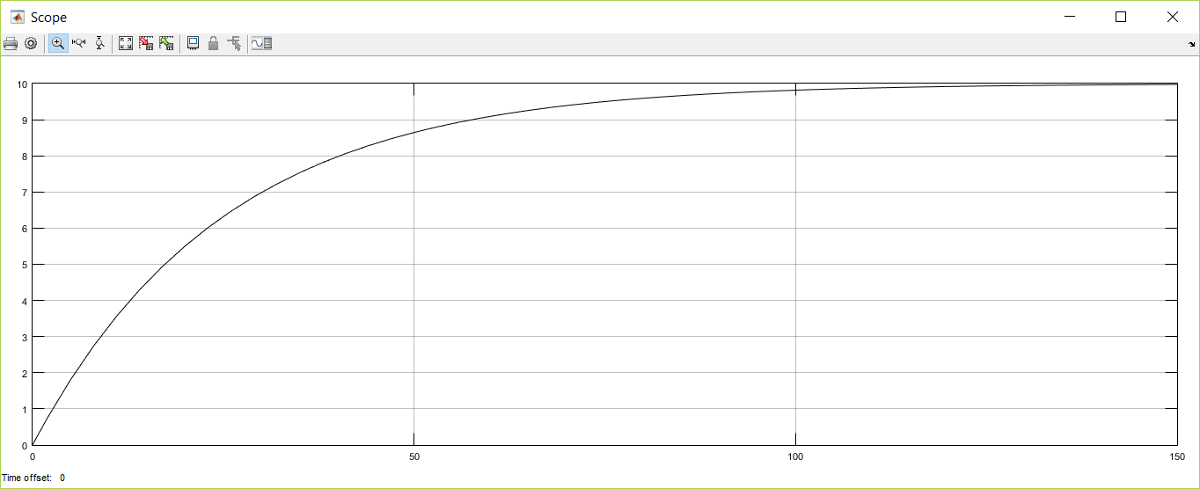

Fig (b): v vs t when stop time=150sec

From this graph, we observe that the system has a steady-state velocity of about 10 m/s, and a time constant of about 25 seconds. Let's check these results with our original equation. For a step input of F = 400 N, the system equation is:

$$1000\frac{dv}{dt}+40v=400$$

Setting dv/dt = 0 gives a steady-state velocity of 10 m/s, a result which agrees with the velocity graph above. To find the time constant of the system the characteristic equation as shown below can be used. 1000s + 40 = 0

Solving this gives the characteristic root, s = -0.04, and thus the time constant is indeed 25 seconds (τ = -1/s), as in the above the graph.

**SUBSYSTEMS**

*SIMULINK* subsystems provide a capability within *SIMULINK* similar to subprograms in traditional programming languages.

**Example-7**

To encapsulate a portion of an existing *SIMULINK* model into a subsystem, consider the *SIMULINK* model shown below and proceed as follows:

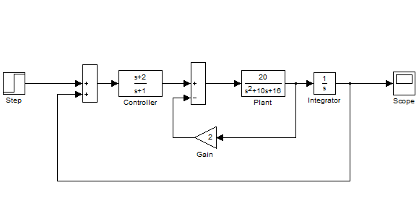

1. Select all the blocks and signal lines to be included in the subsystem with the bounding box as shown.

2. Choose Edit and select Create Subsystem from the model window menu bar. *SIMULINK* will replace the select blocks with a subsystem block that has an input port for each signal entering the new subsystem and an output port for each signal leaving the new subsystem. *SIMULINK* will assign default names to the input and output ports.

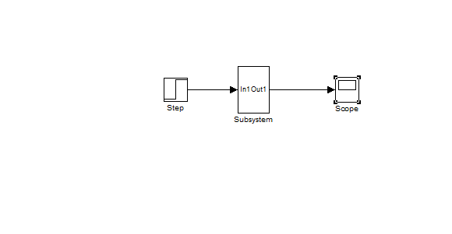

**Exercise:**

1. For the systems shown below draw the block diagram using SIMULINK see the output in the scope with respect to input

Ans:

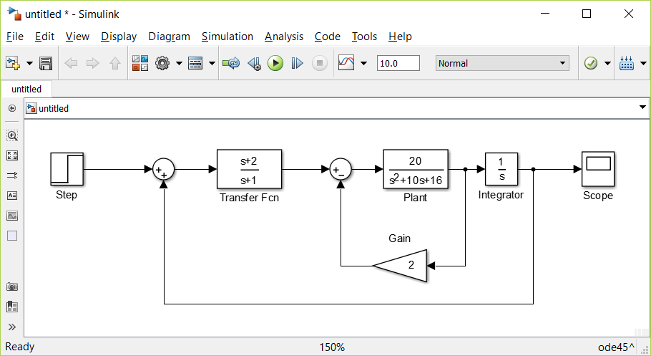

Fig: Complete system

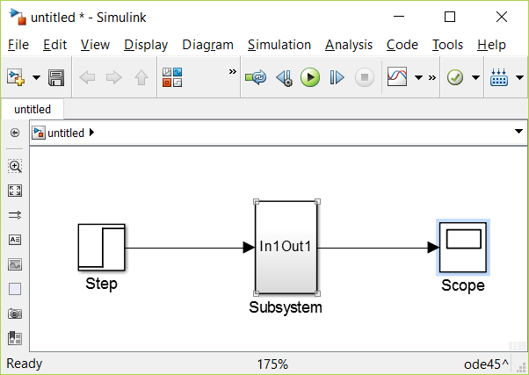

Fig Creating a subsystem

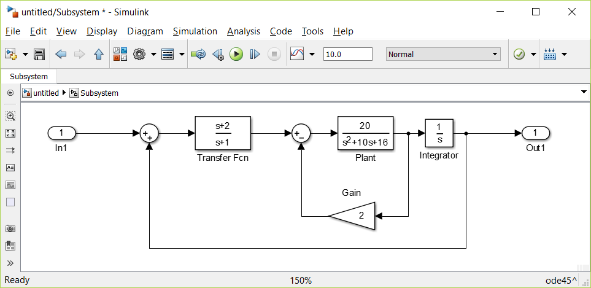

Fig: Subsystem diagram

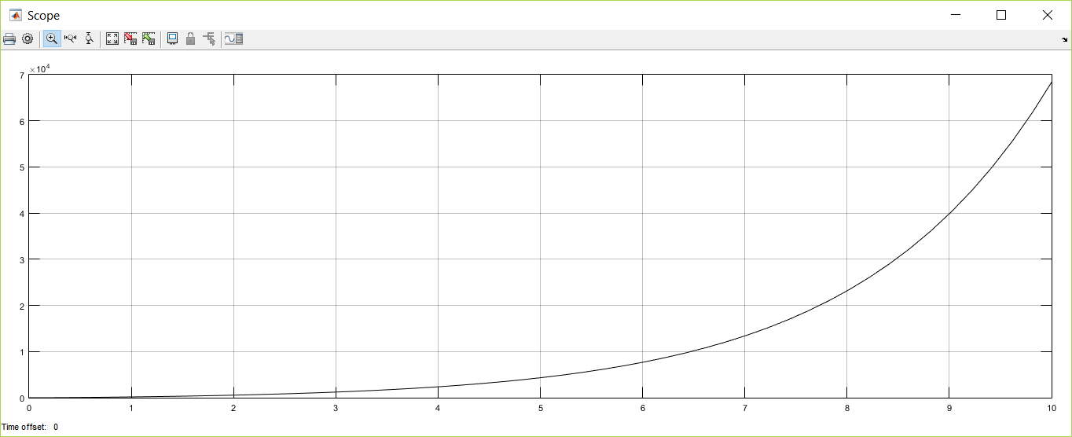

Fig: Output graph

a)



Consider u(t) a unit step input and i(t) the output; assume L = 0.01 and R = 0.01 and zero initial conditions.

Ans:

The differential equation representing the system is

$$L\frac{di}{dt}=u-iR$$

Here:

L =0.01 H and R = 0.01 ohm

This system will be modeled in Simulink by using the system equation as above.

$$\frac{di}{dt}=\frac{u-iR}{M}=\frac{u-0.01i}{0.01}$$

To model this equation, insert a Sum block, two Gain blocks and an integrator block into a new model window. Change the parameters of the blocks as per the requirement.

*System Response to Step Input*

To simulate the system the applied input u is to be specified. Assume step input of u = 400V at t = 0. Insert a Step block from the Sources subfolder into the model, and add a Scope block from the Sinks subfolder to monitor the system's current, i.

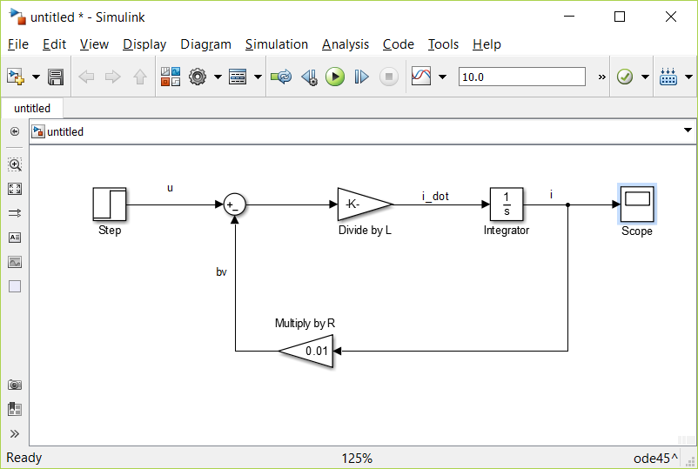

*System Response to Step Input*

To simulate the system the applied input u is to be specified. Assume a step input of u=400 at t = 0. The Step block must be modified to correctly represent the system. Double-click on it and change the Step Time to 0 and the Final Value to 400. The Initial Value can be left as 0, since the u step input starts from 0 at t = 0. The Sample Time should remain 0 so that the Step block's input is monitored continuously during simulation.

The output i can be seen in the graph shown below

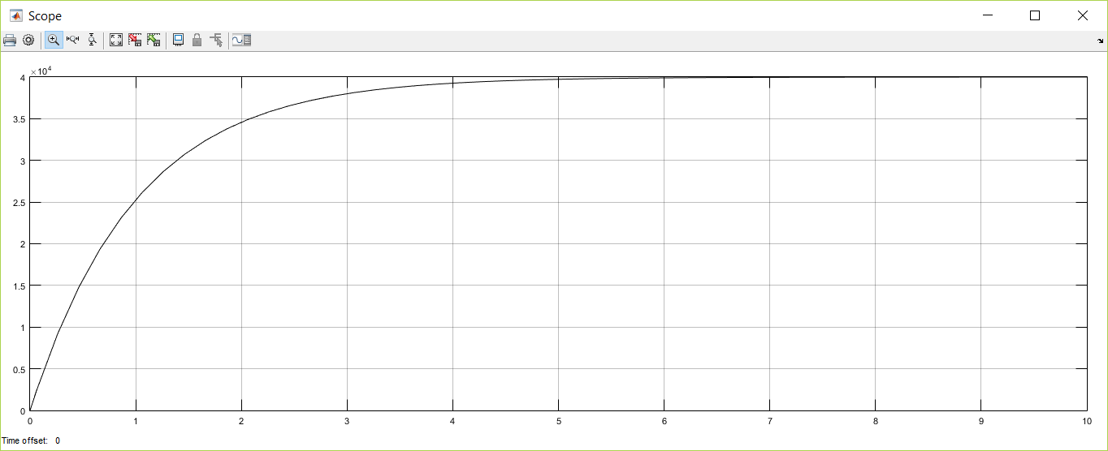

Fig: i vs t

b)



Consider F(t) a step input and x(t) the output; assume m = 2Kg, K= 32 and B = 2 N-s/m and zero initial conditions.

Ans:

The force equation of the system is

$$m\frac{d^{2}x}{{dt}^{2}}+B\frac{dx}{dt}+Kx=F(t)$$

This system will be modeled in Simulink by using the system equation as above.

$$\frac{d^{2}x}{{dt}^{2}}=\frac{1}{m}\left[F\left(t\right)-B\frac{dx}{dt}-Kx\right]$$

Here m = 2Kg, K= 32 and B = 2 N-s/m

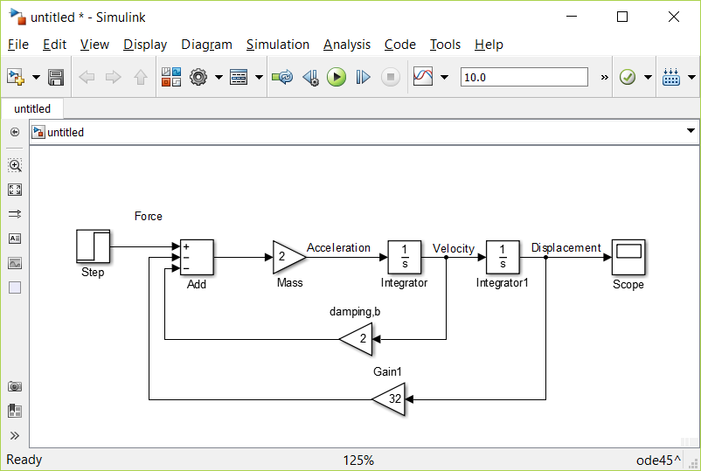

*System Response to Step Input*

To simulate the system the applied input u is to be specified. Assume a step input of F=10 at t = 0. The Step block must be modified to correctly represent the system. Double-click on it and change the Step Time to 0 and the Final Value to 10. The Initial Value can be left as 0, since the F step input starts from 0 at t = 0. The Sample Time should remain 0 so that the Step block's input is monitored continuously during simulation.

The output displacement x can be seen in the graph shown below

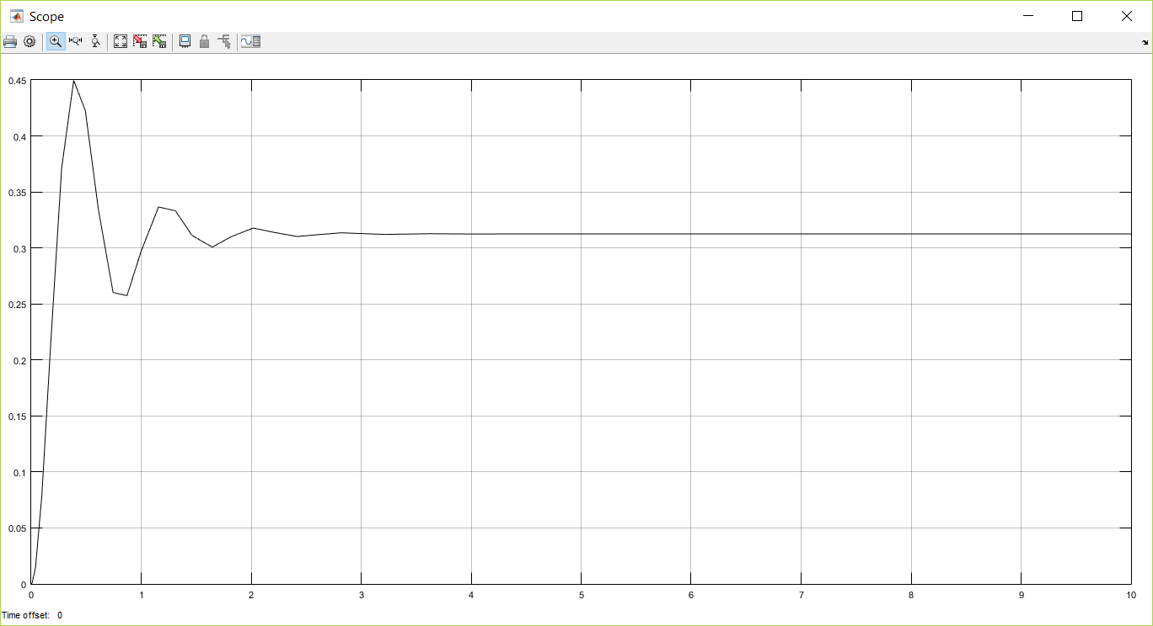

Fig: x vs t

1. For the system defined by the equation

$$2\frac{d^{3}y}{{dt}^{3}}+4\frac{d^{2}y}{{dt}^{2}}+8\frac{dy}{dt}+10y=10u\left(t\right)$$

Draw the SIMULINK block diagram and plot the output response y(t) with respect to u(t).

Ans:

The equation of the system is

$$2\frac{d^{3}y}{{dt}^{3}}+4\frac{d^{2}y}{{dt}^{2}}+8\frac{dy}{dt}+10y=10u\left(t\right)$$

This system will be modeled in Simulink by using the system equation as above.

$$\frac{d^{3}y}{{dt}^{3}}=\frac{1}{2}\left[10u\left(t\right)-4\frac{d^{2}y}{{dt}^{2}}-8\frac{dy}{dt}-10y\right]$$

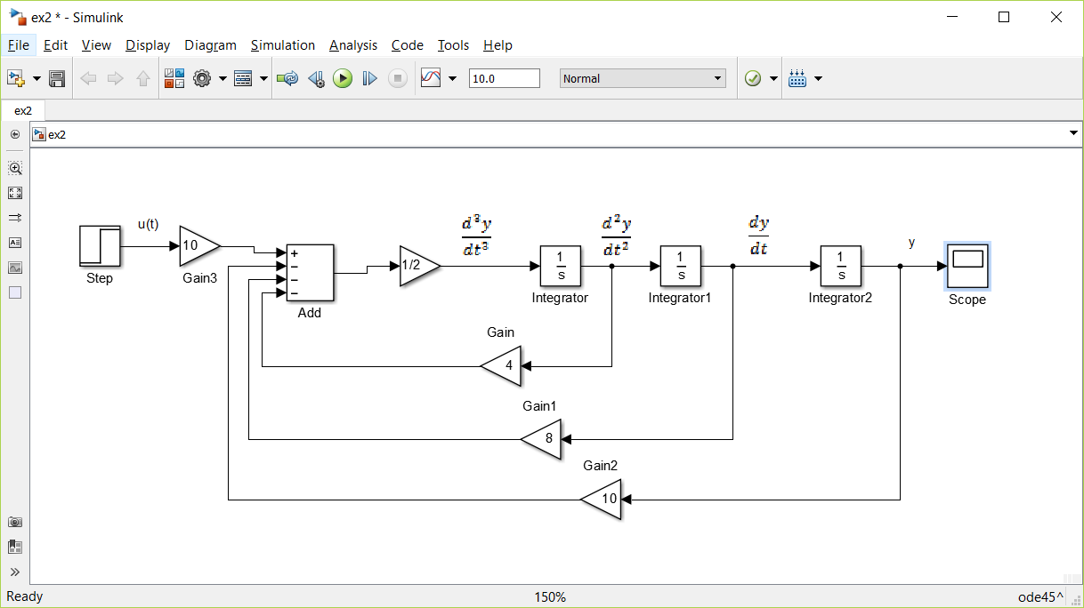

*System Response to Step Input*

To simulate the system the applied input u is to be specified. Assume a step input of u=10 at t = 0. The Step block must be modified to correctly represent the system. Double-click on it and change the Step Time to 0 and the Final Value to 10. The Initial Value can be left as 0, since the u step input starts from 0 at t = 0. The Sample Time should remain 0 so that the Step block's input is monitored continuously during simulation.

The output y can be seen in the graph shown below

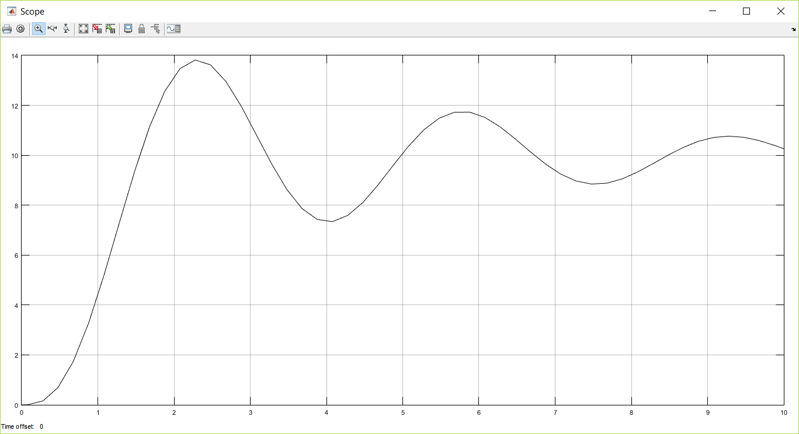

Fig: y vs t